Installation of FRC 2017 Development Software

1. Put NI Software for FRC 2017 distribution DVD in optical drive.
2. Select Run autorun.exe from AutoPlay dialog.  
   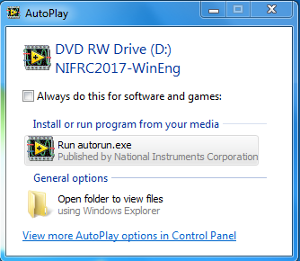
3. Select “Install Everything for LabVIEW Development”.  
   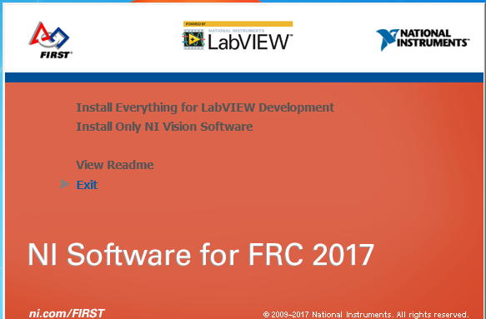
4. Press Next.  
   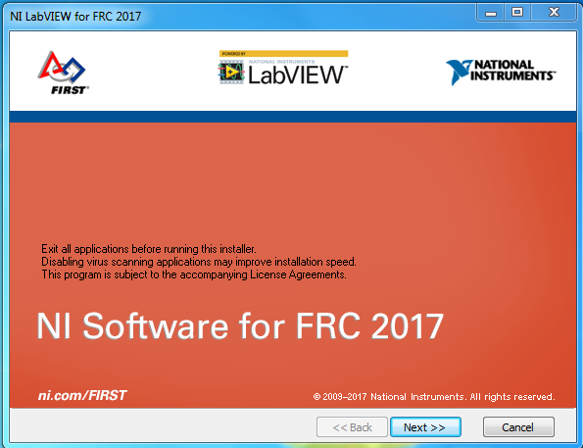
5. Leave all items selected for installation, as they are by default, and press Next.  
   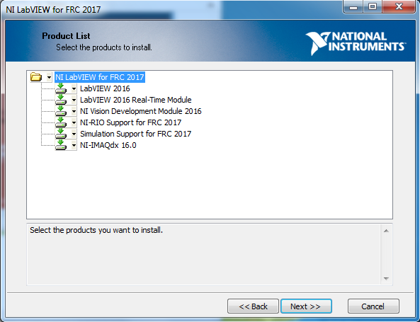
6. Enter VBTCFRC2017 as the Full Name. Enter the serial number M82X14158. This serial number is printed on the label on the back of the NI Software for FRC envelope. Then, press Next.  
   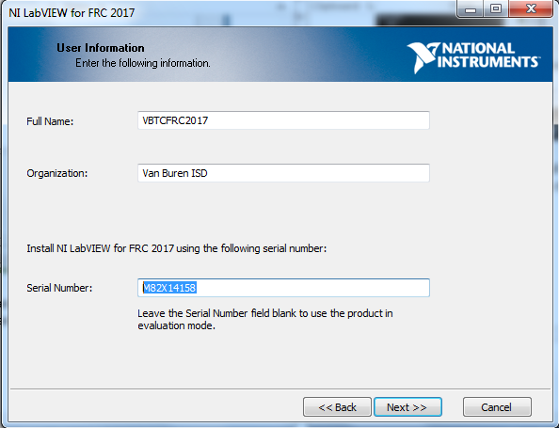
7. Leave the paths as supplied by default and press Next.  
   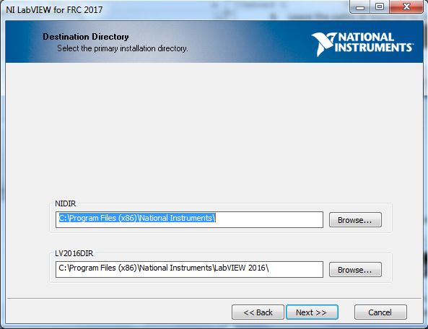
8. Press the I accept… radio button. This pertains to each of the three agreements associated with each of the three tabs. Press Next. This occurs twice.  
   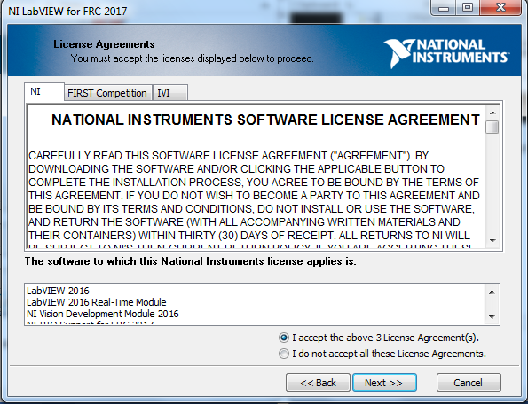
9. This screen lists the software to be installed. Press Next.  
   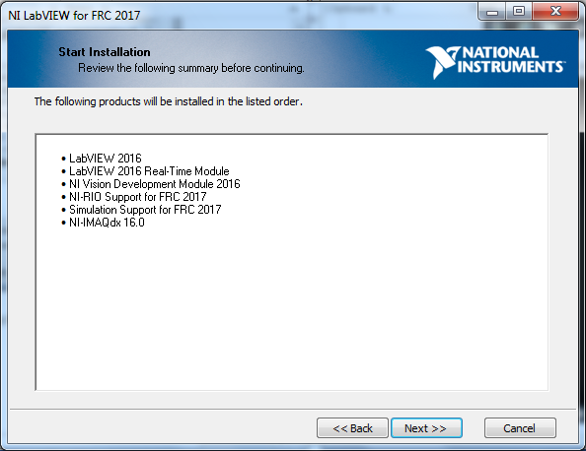
10. Installation begins. This takes a long time.  
    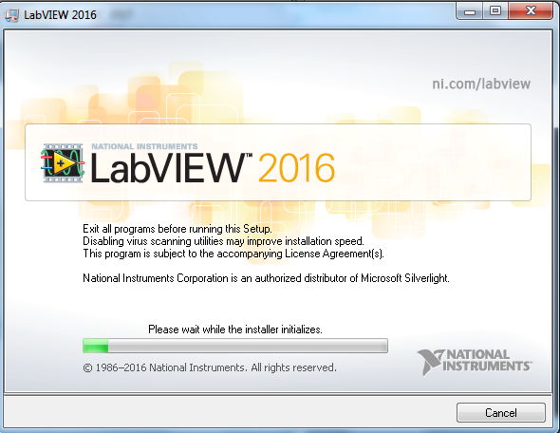
11. When it finishes, this appears. Press Next.
12. 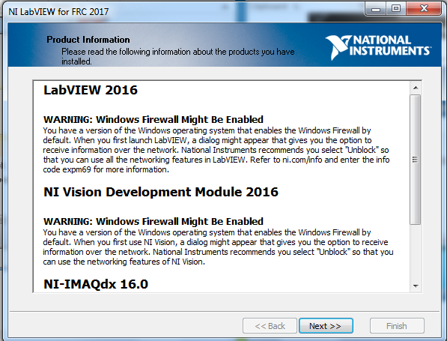
13. An installation summary is shown. Leave the “Run License Manager” box checked, and press Next.  
    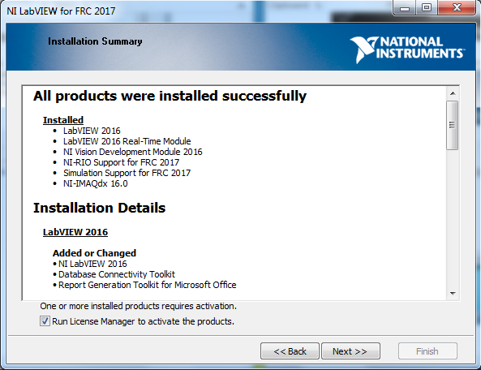
14. This appears next. Press the Next button.  
    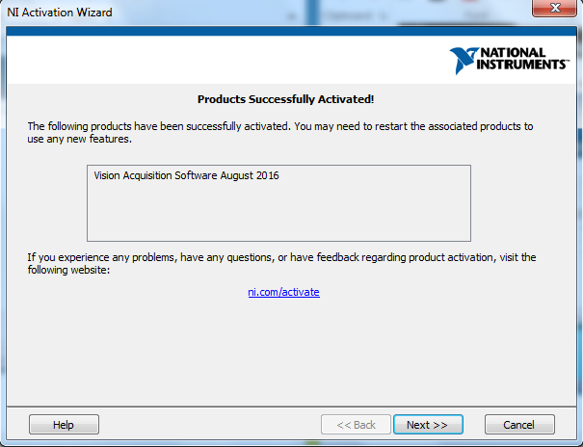
15. This appears next. Leave the “Automatically Activate Through…” radio button selected and press the Next button.  
    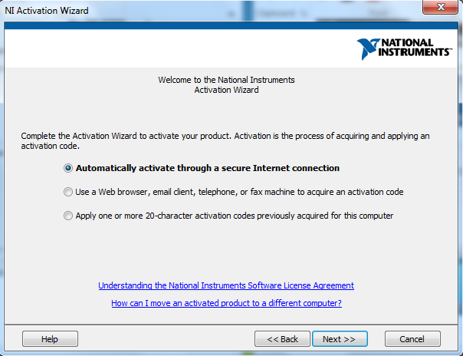
16. This appears next, with the serial numbers pre-filled in the text boxes. Press the Next button.  
    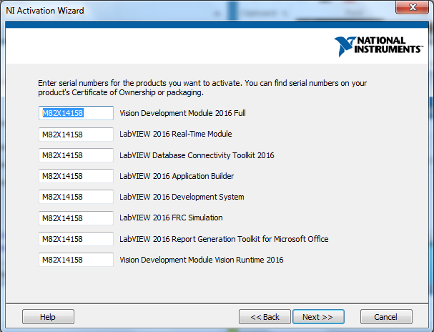
17. Enter an NI User Account ED and password, then press Next.  
    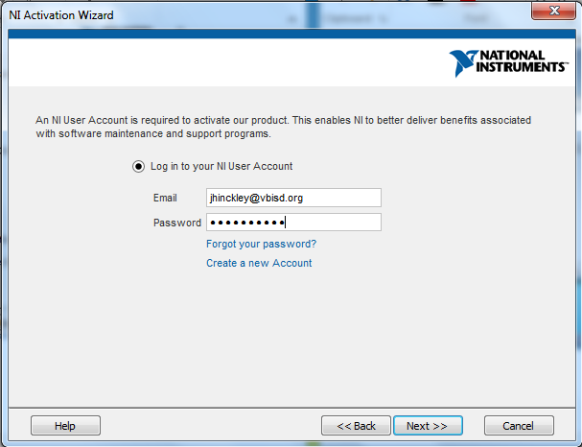
18. This appears next. Press the Next button.  
    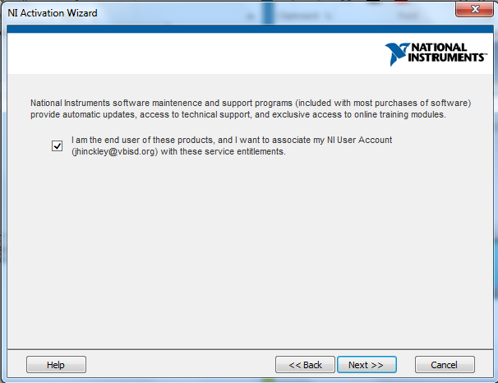
19. Here’s the next screen. Press Next.  
    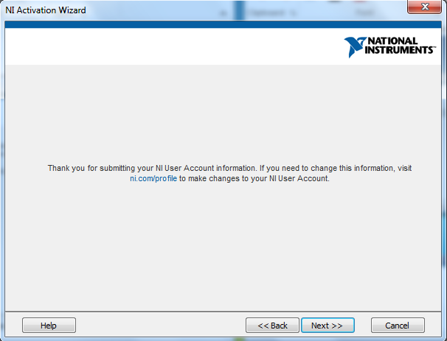
20. Activation proceeds…  
    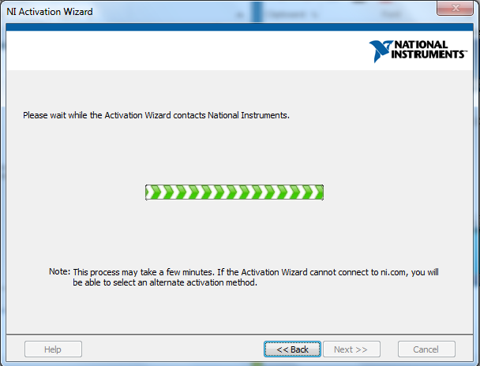
21. When activation completes, press the Finish button.  
    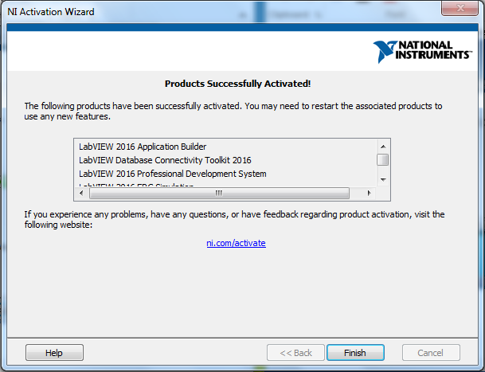
22. Restart the computer.  
    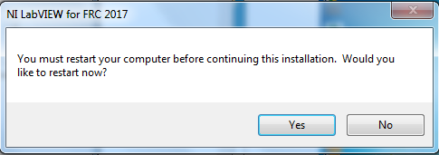

Installing the FRC 2017 Update

This will install the LabVIEW update, the FRC driver station and FRC utilities.

1. Download the update from   
   <http://www.ni.com/download/first-robotics-software-2015/5112/en>  
   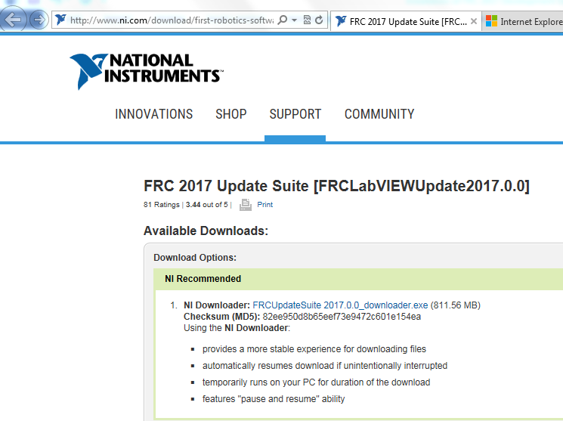
2. Select the recommended NI downloader:  
   http://lumen.ni.com/nicif/US/GB_NIDU/content.xhtml?du=http://www.ni.com/download/first-robotics-software-2015/5112/en/
3. Need to log in to NI account.  
   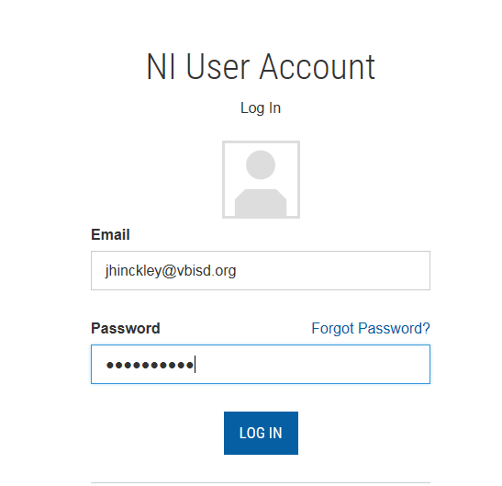
4. You will be asked if you want to run the downloader or save it. Select run.  
   
5. You will be presented with a query as to where to save the update. Use the default desktop choice.   
   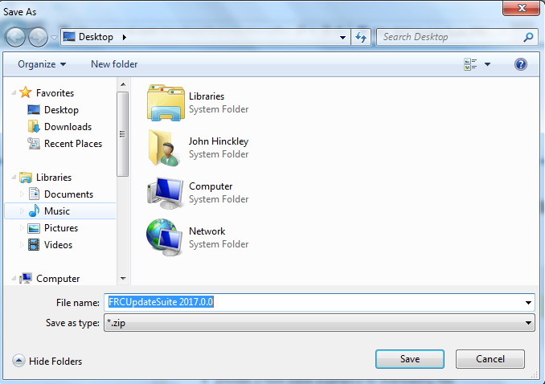
6. This appears and takes a while to run.  
   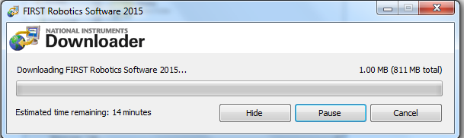
7. When the download completes, this appears. Press the Open button.  
   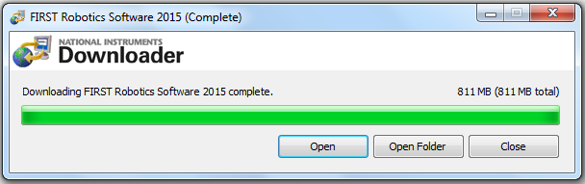
8. Select the FRC update suite and press the Extract To button in the toolbar.  
   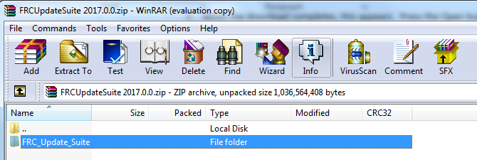
9. Keep the default path (your desktop) and extract by pressing the OK button.  
   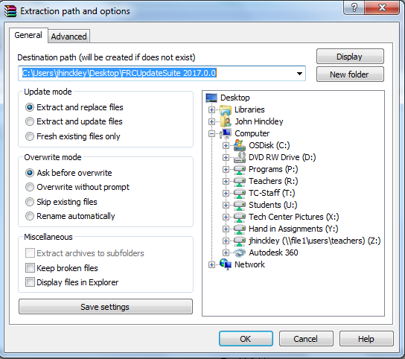
10. It looks like this while it is extracting.  
    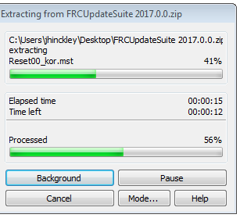
11. Open the extracted folder to reach the location of setup.exe. Double click on setup.exe to run it.  
    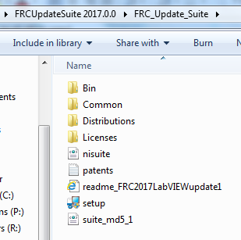
12. This is the initial screen of the update. Press the Next button.  
    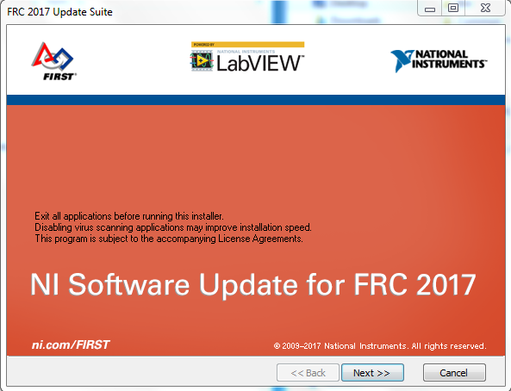
13. Leave the product list as it appears with all items selected.  
    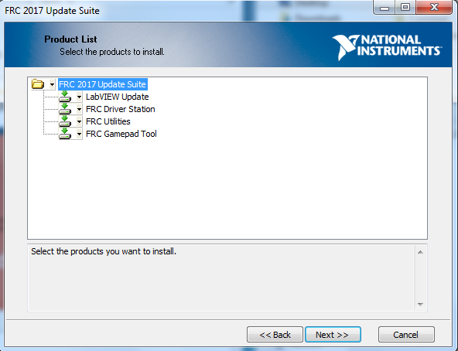
14. Uncheck Search for… box and press Next.  
    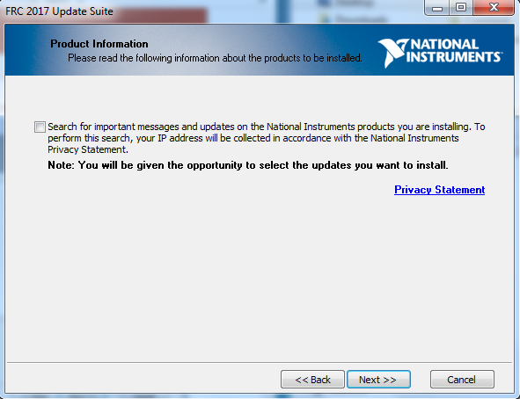
15. Enter VBTCFRC2017 as the Full Name. Enter the serial number M82X14158. This serial number is printed on the label on the back of the NI Software for FRC envelope. Then, press Next.  
    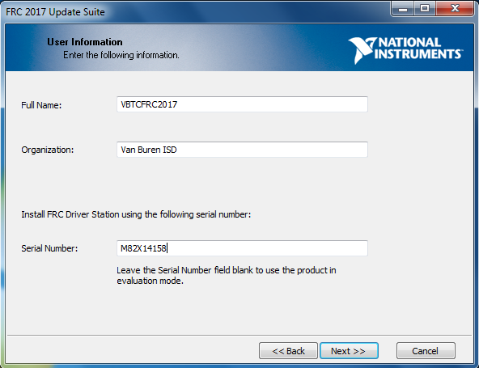
16. Accept the license agreements on the next two screens.
17. Installation commences. When done, check the Run License Manager box and press the Next button.  
    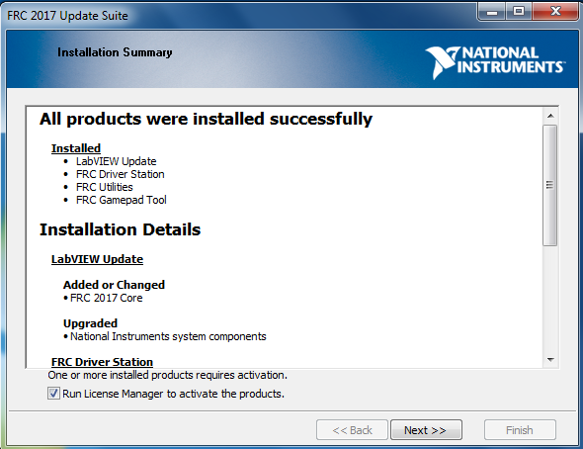
18. Leave the default selected (Automatically activate…) and press Next.  
    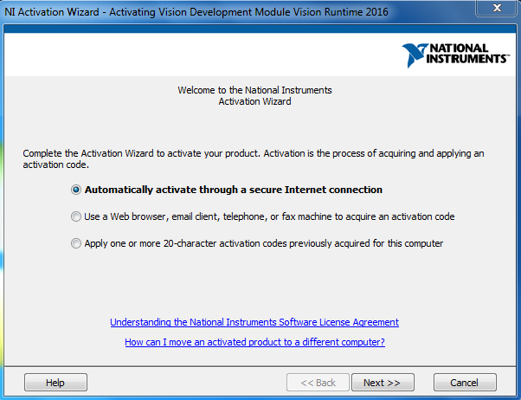
19. Leave the provided serial number and press the Next button.  
    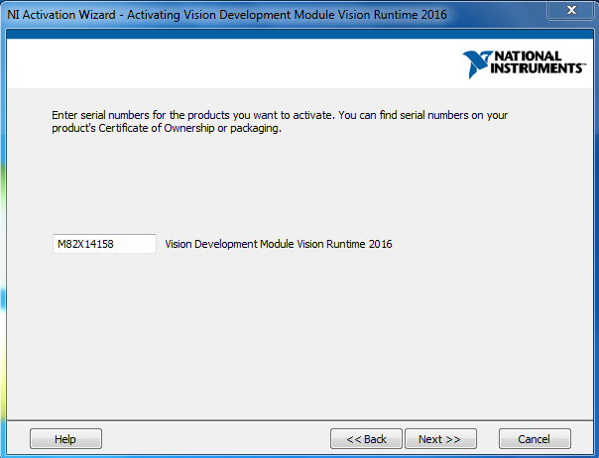
20. Enter a valid email and password.  
    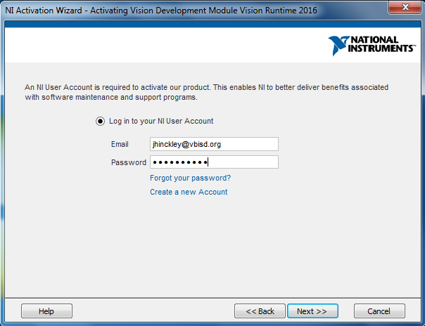
21. Check the box and press Next.  
    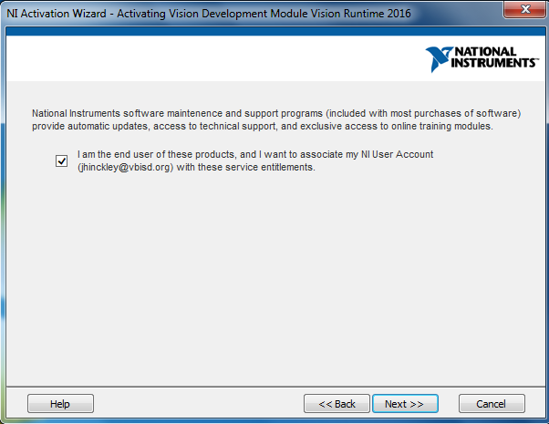
22. When done, this appears. Press the finish button.  
    